Universität Salzburg PS: Understanding Fiction
Fachbereich Anglistik und Amerikanistik Instructor's Name
SS 2018

Please Insert the Title of Your Paper Here

Student Name
24 May 2018 Student Number

CONTENTS
Introduction 1
1. Chapter Headline of First Chapter 1
2. Chapter Headline of Second Chapter 2
3. Chapter Headline of Third Chapter 3
4. Chapter Headline of Fourth Chapter 4
Conclusion 4
Bibliography 6

Introduction
This sample paper can be read alongside, before or after reading the "Style Sheet for Papers in Literary and Cultural Studies" and is intended to illustrate some of its rules for writing term papers.
This dummy paragraph is designed to show you what your paper should look like on the page. The first line of a new paragraph is indented 1.25 cm, but no indentation is used at the beginning of a paper or of a new chapter or section. Use block justification and 1.5 line-spacing throughout the document so that your instructor has enough space for his or her comments. Use 12pt Times New Roman font, set the margins of your document to 3 cm on all sides, and insert page numbers centred at the top of the page. Mind also that the title of the paper and, if you want to use chapter divisions, all chapter headlines are written in Title Case, which means that all words except articles, prepositions and conjunctions are capitalized.
In the introduction to your paper you ideally give a general introduction to the topic that immediately catches your reader's interest. You should then state clearly what the topic of your paper is and present the primary text(s) you are dealing with. Furthermore, it is crucial to say what you want to show in this paper and thereby formulate a central thesis of your paper. Announce the structure of your paper in order to give your reader an overview of what he or she can expect from reading your paper. In the following this paper will outline basic information about paragraphs, about how to integrate quotations into the running text, about how to put titles of various types of publications into the text or the bibliography, and finally about bibliographies in general.

Chapter Headline of First Chapter
In the main part or main body of your paper guide your reader by grouping your ideas into coherent paragraphs, and by linking the paragraphs with connecting words and phrases. Notice that the first sentence of the paragraph often serves as a topic sentence, which all paragraphs need to have. With regard to the length of your paragraphs, the author of The Oxford Guide to Writing, Thomas Kane, explains that it is determined by "subject, purpose […] and individual preference" (67), but he considers a length of 120 to 150 words ideal for a well-developed paragraph.
You may divide the main part of a lengthy paper into several chapters. All chapters should be logically arranged, and they should have roughly the same length. This paper, therefore, does not really conform to this rule, since the first and the second chapter vary considerably in length.

Chapter Headline of Second Chapter
Support your argument with quotations from the primary text and from secondary sources. It is important to always explain and discuss the quotations you give as they do not speak for themselves. Make clear how a quotation from the primary text illustrates the point you want to make and how the argument made by a critic supports or challenges your own argumentation.
There are two main types of quotations: short quotations and long quotations. Short quotations are integrated into the running text like this: "This is a quotation shorter than three lines and is thus inserted in the main text" (Chopin 44). The author's name and the page reference are given in parenthesis right after the quotation, paraphrase, or summary. All long quotations are marked by indentation. The following quotation, for instance, shows how to format a quotation of more than four lines of prose, i.e., passages taken from novels, short stories, critical texts or any other type of text written in full sentences and coherent paragraphs:

This is a quotation which exceeds four lines and is therefore indented 0.5 cm at both margins. You do not need to put quotation marks here, since the block format already indicates that this is a quotation. Please use single-spaced lines. Put the name of the author and the page reference in parentheses at the end of the quotation. (Poe 186)

Note that the quotation is separated from the main text by blank lines and that the line following your quotation is not indented (except if it indeed should mark a new paragraph).
Secondly, when quoting up to three lines of poetry, you should insert the lines into the main text and divide these lines with a dash, adding line numbers in parenthesis: "I love thee to the level of every day's / Most quiet need, by sun and candle-light" (Barrett Browning 5-6). For more than three lines of poetry, indent the quotation and keep the formatting as close to the original as possible.

Love bade me welcome, yet my soul drew back,
Guilty of dust and sin.
But quick-ey'd Love, observing me grow slack
From my first entrance in,
Drew nearer to me, sweetly questioning
If I lack'd anything. (Herbert 1-6)

Thirdly, when quoting dialogue from a play, set aside and indent the quotation, and put the name of the character at the beginning of the line. Add line or page numbers in brackets. William Shakespeare's plays present a special case, since usually the indication of Act, Scene and line numbers suffices and no page reference is necessary. Needless to say, the edition you have used will have to be listed in the bibliography. The following quotation is taken from William Shakespeare's Much Ado about Nothing (1598/99):

LEONATO. I know not. If they speak but truth of her,
These hands shall tear her; if they wrong her honour,
The proudest of them shall well hear of it.
Time hath not yet so dried this blood of mine,
Nor age so eat up my invention,
Nor fortune made such havoc of my means,
Nor my bad life reft me so much of friends,
But they shall find, awaked in such a kind,
Both strength of limb and policy of mind,
Ability in means and choice of friends,
To quit me of them throughly. (4.1.189-199)

If you quote dialogue from a film or TV-show, add time indications for all references to the film or TV-show.

CECILIA. Another six years of student life?
ROBBIE. How else do you become a doctor?
CECILIA. You could get a Fellowship now, couldn't you? With your First.
ROBBIE. But I don't want to teach …

He breaks off, looks away for a moment; then turns back to her.

ROBBIE. I said I'd pay your father back.
CECILIA. That's not what I meant at all. (Atonement 00:21:11 - 00:22:49)

If you want to insert a screen-shot into your paper to illustrate visual characteristics of a certain shot or scene, you can easily do so using the Snipping Tool, which is included in the operating system Windows, running on most personal computers. The snapshot function in the vlc-player works fine as well. Each image needs to be accompanied by the exact time indication. The following stills are taken from the film Life of Pi, directed by Ang Lee and released in 2012. By numbering your stills, you can also easily refer to them within your running text (see Fig. 1).
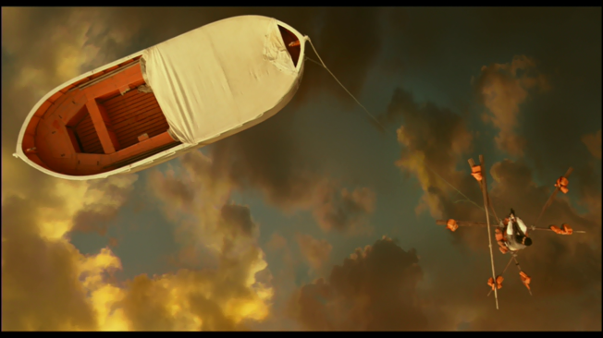  Fig. 1 - 00:55:08 | 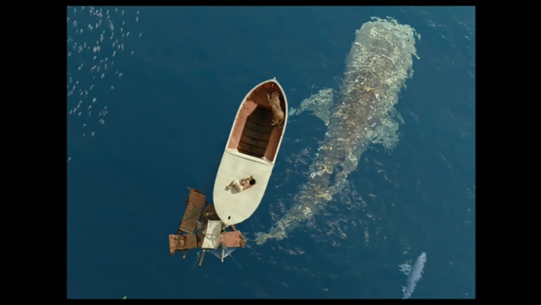  Fig. 2 - 01:19:58

Chapter Headline of Third Chapter
If you mention titles in your paper, italicize the titles and subtitles of publications that have been published separately (i.e., independently, in their own binding) such as monographs, journals, newspapers, novels, plays, operas, films, and TV-series (e.g. The Awakening; Stranger Things). Use quotation marks for works not published separately, namely parts of publications such as scholarly articles in journals or anthologies, newspaper articles, poems, short stories within a collection, or single episodes of TV-series (e.g., Kate Chopin, "The Story of an Hour"; Season 1 Episode 2: "The Big Bran Hypothesis" of The Big Bang Theory).
Thus, you would write in your running text: "The Dead" was written in 1906, considerably later than most of the other stories in Dubliners. However, it gets a bit more complicated if the title appears within another title that needs quotation marks, or is mentioned within a quotation. In this case you need to change double to single quotation marks: In his article, "James Joyce's 'The Dead': A Psychological Interpretation," John Smith points out...

Chapter Headline of Fourth Chapter
All papers, even those which explore only the primary text under discussion, are required to have a bibliography (also called Works Cited). The bibliography should include all the works which have contributed ideas or information to your essay. The list should be in alphabetical order of authors' surnames and single spaced. It is recommended to indent the second and following lines of each item by 0.7 cm.
The format used for papers in literary and cultural studies corresponds with the one suggested by the MLA (Modern Language Association). Each entry normally consists of three main parts: author, title, and details of publication. Each part is followed by a full stop. For every entry, you must determine the medium of publication: most entries will likely be listed as Print or Web sources, but other possibilities may include CD-ROM or DVD. If you do not spot an entry for the kind of source you need to document in the Style Sheet, consult http://owl.english.purdue.edu/ or a recent edition of the MLA Handbook.

Conclusion
In the conclusion you sum up the main points you have made in your paper. If you go through your essay and sum up each paragraph in one or two sentences, you will not only see whether your paper follows a clear and logical structure, but you will also have an almost finished conclusion at hand. Refer back to your thesis statement and make a concluding statement (but no new argument). In this section there is also room to formulate questions that might extend the initial scope of your paper and/or place your claims in a larger context.
On the next page you will find a sample bibliography focussing on the film adaptation of F.Scott Fitzgerald's The Great Gatsby (1925) by Baz Luhrmann (2013), which was originally included in a paper about the representation of the upper class in the film. Note that such ready-made bibliographies, which are included in all scholarly publications, can also be helpful during your own research in order to find relevant sources regarding your own paper.

Bibliography

"Aristocracy." The Oxford English Dictionary. OED Online Edition. 2014. Web. 23 January 2014.
Bruccoli, Matthew J. "A Brief Life of Fitzgerald". The F. Scott Fitzgerald Society. Web. 25 January 2014. <http://www.fscottfitzgeraldsociety.org/biography/index.html>.
Cousineau, Thomas. "The Great Gatsby: Romance or Holocaust?." Contagion: Journal of Violence, Mimesis, and Culture 8 (Spring 2001): 21-38. Project MUSE. Web. 20 January 2014.
Egert, Charles. "Love and Homicide in the Jazz Age Novel." Journal of Narrative Theory 34.1 (2004): 54-87. Project MUSE. Web. 20 January 2014.
Fitzgerald, F. Scott. The Great Gatsby. 1925. Stuttgart: Reclam, 1995. Print.
Froehlich, Maggie Gordon. "Gatsby's Mentors: Queer Relations between Love and Money in The Great Gatsby." The Journal of Men's Studies 19.3 (2011): 209-226. MLA International Bibliography. Web. 20 January 2014.
Giles, Paul. "A Good Gatsby: Baz Luhrman Undomesticates Fitzgerald." Commonweal July 12 (2013): 12-15. MLA International Bibliography. Web. 20 January 2014.
Goldsmith, Meredith. "White Skin, White Mask: Passing, Posing, and Performing in The Great Gatsby." Modern Fiction Studies 49.3 (2003): 443-468. Project MUSE. Web. 20 January 2014.
Great Gatsby, The. Dir. Baz Luhrmann. Perf. Leonardo DiCaprio, Tobey Maguire, and Carey Mulligan. Warner Bros. Pictures, 2013. DVD.
Kyvig, David E. Daily Life in the United States, 1920-1940: How Americans Lived Through the "Roaring Twenties" and the Great Depression. Chicago: Ivan R. Dee, 2004. Print.
Luhrmann, Baz, and Craig Pearce. "The Great Gatsby Screenplay." 2013. Web. 17 January 2014. <http://www.warnerbros2013.com/assets/pdf/greatgatsby_sp.pdf>.
Scholz, Anne-Marie. "Adaptation as Reception: How a Transnational Analysis of Hollywood Films Can Renew the Literature-to-Film Debates." American Studies 54.4 (2009): 657-682. JSTOR. Web. 4 February 2014.
Soule, Goerge Henry. Prosperity Decade: From War to Depression: 1917-1929. 1947. New York: M. E. Sharpe, 1989. Print.

