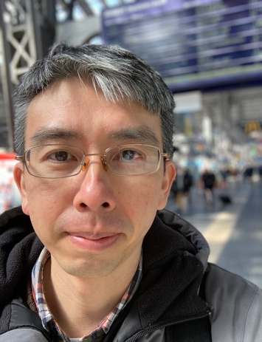
Yen-Chi Yang ,楊彥騏
02. Oktober 1978

Kontakt yen-chi.yang@stud.sbg.ac.at
Augustinchou2004@gmail.com
Zhen 4St. 77-2, Taoyuan City(330), Taiwan
Hauptbetreuer: Assoz. Prof. Dr. Martin Rötting (Paris Lodron Universität )
Nebenbetreuer: Prof. Sedmak Clemens <clemens.sedmak@plus.ac.at>

Berufserfahrung

10/2021 – PhD Student, Religious Studies, Salzburg

09/2017 – 06/2018 Lecturer, Cardinal Tien College, Taiwan

06/2009 – 08/2015 Train Master, Taiwan High Speed Rail

Ausbildung

10/2020 – 10/2021 Exchange Student, Katholische Fachtheologie, Innsbruck

Doktoratsstudium - Philosophy Studies

06/2018 – 09/2021 PhD Student, NCCU, Taiwan

Doktoratsstudium - Religious Studies

09/2015 – 06/2017 MA, Religious Studies, Chung Yuan Christian Universiity, Taiwan

Title Of Thesis: The Eucharist is an Action and A Meal : An Introductory Study of the Historical Transformation of the Eucharist with Special Reference to Thomas O’Loughlin’s Historical Theology

Sprachen
Englisch

Deutsch

Chinesisch

Lehraufträge

06/2018 – 09/2021 Lehrassistent, NCCU, Taiwan

Referent am Erforschung des Lebens und der religiösen Kultur

10/2018 Seminar, Religious Studies, NCCU, Taiwan

Referent am Seminar: Theological displacement in middle ages - Ibn Rushd and Thomas Aquinas as an example.

Publication List
Books
- O’Loughlin, Thomas; translated by Yen-Chi Yang (2018). The O’Loughlin Anthology: Second Century Church Works and Contemporary Roman Rites. Taoyuan, Taiwan: Bid Culture. ISBN: 978-9869650113.
(Original in Chinese: 多瑪斯奧洛林 著，楊彥騏 譯, 2018.07, 奧洛林選集 — 第二世紀教會著作與當代羅馬禮, 畢德文化, 桃園市, 台灣.)
Journal Articles
- Yang, Yen-Chi (2021). “The Eusebian Apparatus: Thomas O’Loughlin’s Guide and Commentary.” Taiwan Journal of Religious Studies (peer-reviewed, THCI).
Conference Papers
- Yang, Yen-Chi (2021, June). “The Thought of Ibn Sina’s Therapeutic Metaphysics (Book 9, Chapter 4) in Thomas’s Complete Philosophy.” National Chengchi University, Graduate Forum, Online via Google Meet.
- Yang, Yen-Chi (2021, March). “Key Texts in 20th Century Practical Ethics: An Introduction to W.D. Ross and Iris Murdoch.” Graduate Student Paper Presentation, The Life of Philosophy and the Philosophy of Life, Department of Philosophy, National Taiwan University.
- Yang, Yen-Chi (2020, June). “Aquinas and Sufism on the Agency of Love: A Contrastive Study of Nishida Kitaro’s Place and Dialectic.” National Chengchi University, Graduate Forum.
- Yang, Yen-Chi (2019, October). “Understanding Contemporary Nationalism and Colonialism from the Insight of Pang Shiqian’s Nine Years in Egypt.” 10th International Symposium on Islam, Civilisation and Science (ISICAS 2019), National University of Malaysia. Conference Proceedings. ISBN: 978-967-17506-0-5; Publisher: Institute of Islam Hadhari (IIH), Universiti Kebangsaan Malaysia, Bangi, Selangor, Malaysia.
- Yang, Yen-Chi (2019, September). “Liu Zhi’s Mecca Square’s Nature and Principle.” The 3rd Asian Philosophy Postgraduate Forum, Whither Asian Philosophy? Chinese University of Hong Kong. Presented in English at National Chengchi University and in Chinese at the Taiwan Philosophical Society (November 2019).
- Yang, Yen-Chi (2019, June). “Challenges and New Opportunities for the Development of Religions in Taiwan in Light of the Post-2015 Attitudes of Iranian Shiites and the Vatican Curia toward ‘Internal Dissent’.” Graduate Forum, Institute of Religious Studies, National Chengchi University, Room 330106, Centennial Building, Taipei, Taiwan.
Theses
- Yang, Yen-Chi (2017, June). The Eucharist is an Action and a Meal: A Historical-Theological Perspective from Thomas O’Loughlin. MA Thesis, Department of Religious Studies, Chung Yuan Christian University, Taoyuan, Taiwan.
(Original in Chinese: 感恩聖事的起點是一種行動與進餐 — 從多瑪斯奧洛林的歷史神學觀點看感恩聖事歷史的演變, 中原大學宗教研究所碩士論文, 2017.6.)

